A000-AM,C-Taino-Batu Ballgame-Yuke-Andesite-1000 CE

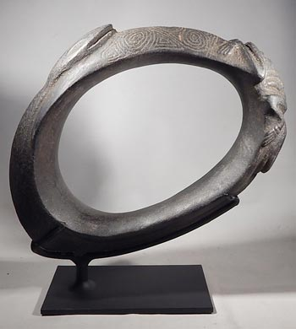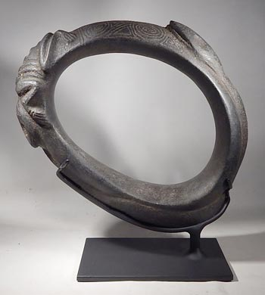

Figs. 1-2. AM,C-Taino-Batu Ballgame-Yuke-Andesite-1000 CE

Case No.:

**Accession No.**

**Formal Label:** AM,C-Taino-Batu Ballgame-Yuke-Andesite-1000 CE

**Display Description:**

Batu was a ballgame held in a ceremonial Batey, a rectangular compacted earthen floor with boundaries of the *Batey* demarcated by rows of large, flat stones, many of which had representations of cemís or spiritual beings.

Each team had twelve men and women players using the Yuke, a leather ceremonial belt. The Captain of the winning team was given a stone Yuke as a commemoration of the *Batu* game. The number of players could always be increased by multiples of twelve.

The game involved the *Batu,* a rubber ball made from the resin of the copey tree (Clusia rosea). It involved boiling grass roots and the copey (Clusia rosea) resin, which formed a paste and which was formed into a ball about 10 cm in diameter which had a very good bounce.

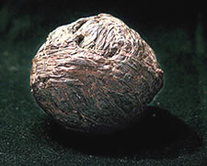

Fig. A *Batu* showing the strings of grass surrounding the inner core of rubber.

The object of the *Batu* game was to launch the Batu in the air with both sides struggling not to drop it on their respective sides, returning it with any part of the body except the hands. The *Batu* could also be bounced off the stones that marked the edge of the playing field; the side to let him roll on the floor lost a point.

It was an important social event, and could be inter-tribal to resolve inter-tribal disputes or to decide the future of a captured enemy or punishment. The spectators sat around the court; Special guests, the chief and his assistants took to their duhos (ceremonial seats).

Fray Bartolome de las Casas , gave a description of the sport (after http://pueblosoriginarios.com/biografias/casas.html):

"I missed one of those in a position of the ball to the other of the other and more rebatiala which was at hand, if the ball came over with his shoulder that made her back like lightning, and when he came down, Presto, putting his right hand on dábanle earth with the tip of the buttock, returning more than one step, the opposing position, in the same way the tornaban with the tip of the buttocks up according to the rules of the game both committed a foul. "

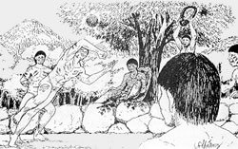

**LC Classification: F1909**

**Date or Time Horizon: 1000 CE**

**Geographical Area: Caribbean**

**Map:**

**GPS coordinates:**

**Cultural Affiliation: Taino**

**Medium: andesite**

**Dimensions:**

**Weight:**

**Condition: original**

**Provenance:**

**Discussion:**

**References:**